**Exercise 1**: Logging Error Messages and Warning Levels

Task: Write a Java application that demonstrates logging error messages and warning levels

using SLF4J.

Step-by-Step Solution:

1. Add SLF4J and Logback dependencies to your `pom.xml` file:

<dependency>

<groupId>org.slf4j</groupId>

<artifactId>slf4j-api</artifactId>

<version>1.7.30</version>

</dependency>

<dependency>

<groupId>ch.qos.logback</groupId>

<artifactId>logback-classic</artifactId>

<version>1.2.3</version>

</dependency>

2. Create a Java class that uses SLF4J for logging:

import org.slf4j.Logger;

import org.slf4j.LoggerFactory;

public class LoggingExample {

private static final Logger logger = LoggerFactory.getLogger(LoggingExample.class);

public static void main(String[] args) {

logger.error("This is an error message");

logger.warn("This is a warning message");

**Solution:**

First,create a java project in IntelliJ IDE.

Next add the dependencies for SLF4J API and LogBack(for SLF4J implementation),in pom.xml.

**Pom.xml:**

<?xml version="1.0" encoding="UTF-8"?>  
<project xmlns="http://maven.apache.org/POM/4.0.0"  
 xmlns:xsi="http://www.w3.org/2001/XMLSchema-instance"  
 xsi:schemaLocation="http://maven.apache.org/POM/4.0.0 http://maven.apache.org/xsd/maven-4.0.0.xsd">  
 <modelVersion>4.0.0</modelVersion>  
  
 <groupId>org.example</groupId>  
 <artifactId>JUnit_Setup</artifactId>  
 <version>1.0-SNAPSHOT</version>  
  
 <properties>  
 <maven.compiler.source>17</maven.compiler.source>  
 <maven.compiler.target>17</maven.compiler.target>  
 <project.build.sourceEncoding>UTF-8</project.build.sourceEncoding>  
 </properties>  
  
 <dependencies>  
   
 <!-- SLF4J API -->  
 <dependency>  
 <groupId>org.slf4j</groupId>  
 <artifactId>slf4j-api</artifactId>  
 <version>1.7.30</version>  
 </dependency>  
  
 <!-- Logback (SLF4J Implementation) -->  
 <dependency>  
 <groupId>ch.qos.logback</groupId>  
 <artifactId>logback-classic</artifactId>  
 <version>1.2.3</version>  
 </dependency>  
 </dependencies>  
  
  
</project>

Now create a java file in the main class named,LoggingExample.java.

**LoggingExample.java:**

package org.example;  
  
import org.slf4j.Logger;  
import org.slf4j.LoggerFactory;  
  
public class LoggingExample {  
  
   
 private static final Logger *logger* = LoggerFactory.*getLogger*(LoggingExample.class);  
  
 public static void main(String[] args) {  
  
   
 *logger*.error("This is an ERROR message");  
  
   
 *logger*.warn("This is a WARNING message");  
  
   
 *logger*.info("This is an INFO message");  
 *logger*.debug("This is a DEBUG message");  
 *logger*.trace("This is a TRACE message");  
 }  
}

Now create a logback.xml file in resources.

**Logback.xml:**

<configuration>  
 <appender name="STDOUT" class="ch.qos.logback.core.ConsoleAppender">  
 <encoder>  
 <pattern>%d{HH:mm:ss.SSS} [%thread] %-5level %logger{36} - %msg%n</pattern>  
 </encoder>  
 </appender>  
  
 <root level="debug">  
 <appender-ref ref="STDOUT" />  
 </root>  
</configuration>

Now run the LoggingExample.java file.

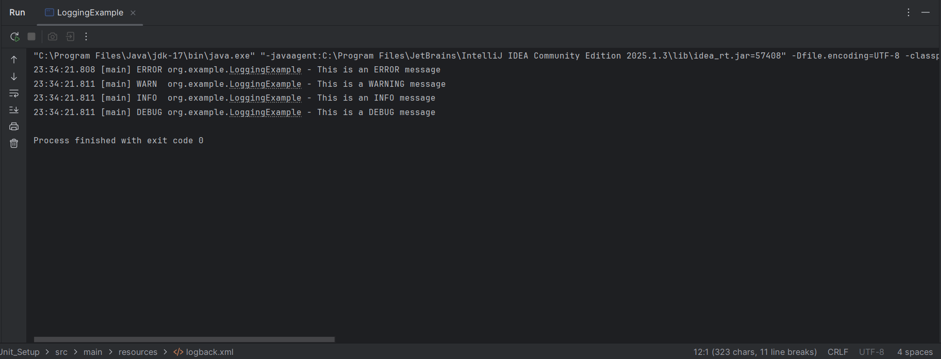**Output:**